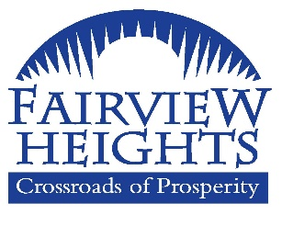
City of Fairview Heights
PUBLIC HEARING AGENDA
10025 BUNKUM ROAD
FAIRVIEW HEIGHTS, IL 62208
April 01, 2025
6:55 p.m.

________________________________________________________________________________________
The City Council meeting will be held in the Council Chambers. Participation (only) join at https://meet.goto.com/COFH or dial in at 1 (786) 535-3211 - Access Code: 800-004-661 - Please mute your phone during the meeting. To install the application: https://meet.goto.com/install.

- Call to order

- Roll Call

- PUBLIC HEARING ANNOUNCEMENT
City of Fairview Heights
2025-2026 Proposed Budget Estimated at $ 38,988,732.00

- Speaking in favor of the subject

- Speaking in opposition of the above subject

- Written comments in favor of the above subject

- Written comments in opposition of the above subject

- Adjournment

